ServiceNow training manual

# Homepage

Setting up your homepage to fit the work that you do.

1. Below main colored bar that runs across the top of the page is a gray bar that appears as the following

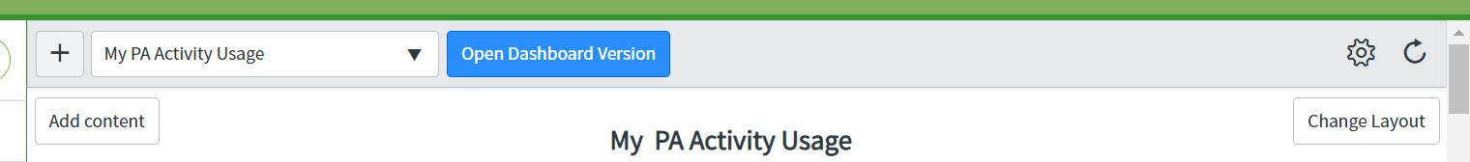

The plus allows you to create a new homepage

The dropdown allows you to select which homepage you would like to view

“Open dashboard version” button opens up your dashboards

The gear button allows you to adjust the refresh interval on your widgets and convert your homepage to a dashboard (discourage doing this)

The circle arrow is to refresh your dashboard immediately

The “Add content” button allows you to select widgets to your homepage

The “Change Layout” button allows you to select the **general** pattern of your widgets.

**Creating your Homepage**

**Adding a report**

Under ”All applications” on the side of the page

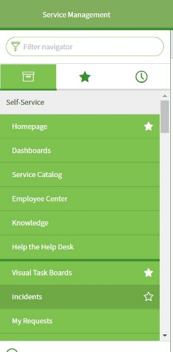

Scroll down to the “reports” section near the bottom of the list and select “View/Run”

The Select the “group” button on the top gray bar



This will bring up all reports that have been created for the ACP on ServiceNow

Select the empty stars adjacent to the reports that you wish to add to your homepage

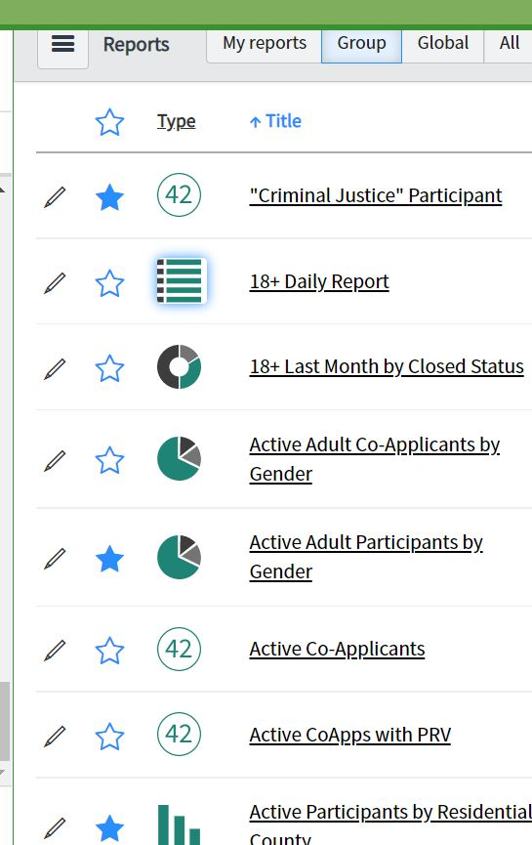

Once you have selected the reports that you would like to be shown on your homepage, return to your homepage, located in your favorites tab.

Select the “Add content” button and go to “<Favorites>”. This will populate the second selection box with all of your “starred” reports. Select the reports you would like to see on your homepage and then submit the action by selecting the “Add here” button at the base of the window.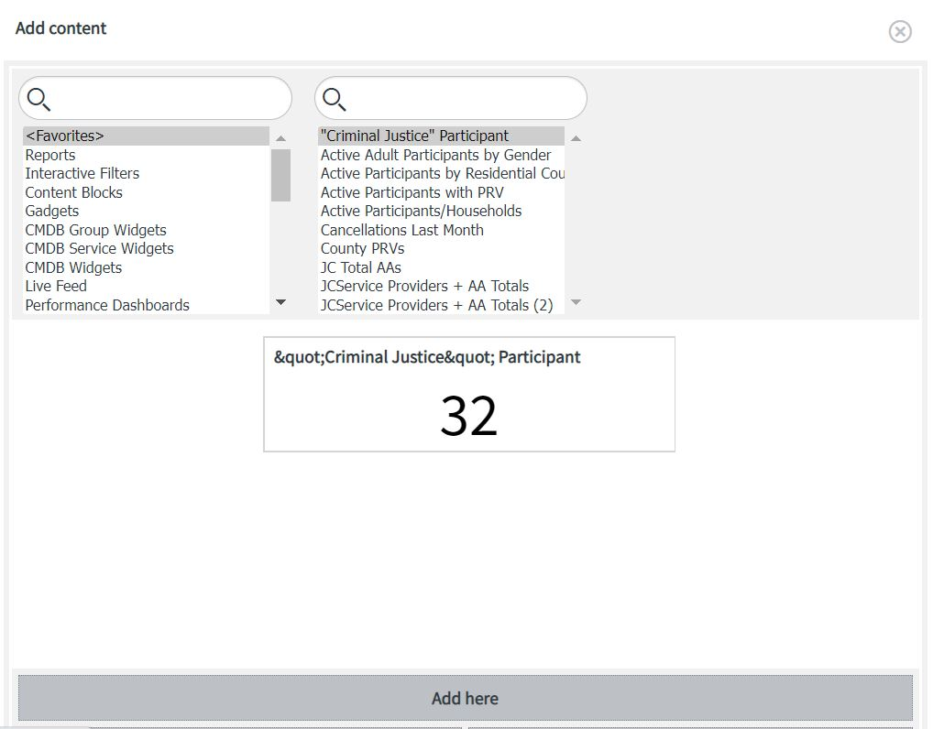

Repeat this process as necessary until you have all of the widgets that you would like. Below is an example of a fully customized Homepage.

*******************Insert Picture**********************************